PROJECT REPORT

**A NOVEL METHOD FOR**

**HANDWRITTEN DIGIT RECOGNITION**

***submitted by***

***PNT2022TMID09695***

Abishek Poddar - Team leader

Jitendra Kumar Thakur - Team Member

Md Imran - Team Member

Anand Kumar – Team Member

Ankit Pranjay – Team Member

**TABLE OF CONTENTS**

**1 INTRODUCTION** 1

PROJECT OVERVIEW 1

PURPOSE 1

**2 LITERATURE SURVEY** 2

EXISTING PROBLEM 2

REFERENCES 2

PROBLEM STATEMENT DEFINITION 3

**3 IDEATION AND PROPOSED SOLUTION** 5

EMPATHY MAP CANVAS 5

IDEATION & BRAINSTORMING 6

PROPOSED SOLUTION 7

PROBLEM SOLUTION FIT 8

**4 REQUIREMENT ANALYSIS** 10

FUNCTIONAL REQUIREMENTS 10

NON FUNCTIONAL REQUIREMENTS 10

**5 PROJECT DESIGN** 13

DATA FLOW DIAGRAM 13

SOLUTION & TECHNICAL ARCHITECTURE 13

USER STORIES 14

**6 PROJECT PLANNING AND SCHEDULING** 16

SPRINT PLANNING AND ESTIMATION 16

SPRINT DELIVERY SCHEDULE 17

**7 CODING & SOLUTIONING** 18

**8 TESTING** 19

TEST CASES 19

USER ACCEPTANCE TESTING 23

DEFECT ANALYSIS 23

TEST CASE ANALYSIS 24

**9 RESULTS** 25

PERFORMANCE METRICS 25

**10 ADVANTAGES & DISADVANTAGES** 27

ADVANTAGES 27

DISADVANTAGES 27

**11 CONCLUSION** 28

**12 FUTURE SCOPE** 29

**APPENDIX** 30

SOURCE CODE 30

GITHUB 41

PROJECT DEMO 41

**CHAPTER 1**

# INTRODUCTION

PROJECT OVERVIEW

Machine learning and deep learning play an important role in computer technology and artificial intelligence. With the use of deep learning and machine learning, human effort can be reduced in recognizing, learning, predictions and in many more areas.

Handwritten Digit Recognition is the ability of computer systems to recognise handwritten digits from various sources, such as images, documents, and so on. This project aims to let users take advantage of machine learning to reduce manual tasks in recognizing digits.

PURPOSE

Digit recognition systems are capable of recognizing the digits from different sources like emails, bank cheque, papers, images, etc. and in different real-world scenarios for online handwriting recognition on computer tablets or system, recognize number plates of vehicles, processing bank cheque amounts, numeric entries in forms filled up by hand (tax forms) and so on.

**CHAPTER 2**

##### LITERATURE SURVEY

EXISTING PROBLEM

The fundamental problem with handwritten digit recognition is that handwritten digits do not always have the same size, width, orientation, and margins since they vary from person to person. Additionally, there would be issues with identifying the numbers because of similarities between numerals like 1 and 7, 5 and 6, 3 and 8, 2 and 5, 2 and 7, etc. Finally, the individuality and variation of each individual's handwriting influence the structure and appearance of the digits.

**REFERENCES**

**R. Bajaj, L. Dey, S. Chaudhari et al**, employed three different kinds of features, namely, the density features, moment features and descriptive component features for c lassification of Devanagari Numerals. They proposed multi classifier connectionist architecture for increasing the recognition reliability and they obtained 89.6% accuracy for handwritten Devanagari numerals.

**Aparna et al,** proposed a method to construct a handwritten Tamil character by executing a sequence of strokes. A structure or shape-based representation of a stroke was used in which a stroke was represented as a string of shape features. Using this string representation, an unknown stroke was identified by comparing it with a database of strokes using a flexible string matching procedure.

**Renata F. P. Neves** has proposed SVM based offline handwritten digit recognition. Authors claim that SVM outperforms the Multilayer perceptron classifier. Experiment is carried out on NIST SD19 standard dataset. Advantage of MLP is that it is able to segment non-linearly separable classes. However, MLP can easily fall into a region of local minimum, where the training will stop assuming it has achieved an optimal point in the error surface. Another hindrance is defining the best network architecture to solve the problem, considering the number of layers and the number of perceptrons in each hidden layer. Because of these disadvantages, a digit recognizer using the

MLP structure may not produce the desired low error rate.

**Improved Handwritten Digit Recognition Using Quantum K-Nearest Neighbor**

**Algorithm (2019)**

*Wang, Yuxiang and Wang, Ruijin and Li, Dongfen and Adu-Gyamfi, Daniel and Tian, Kaibin and Zhu, Yixin*

The KNN classical machine learning technique is used in this research to enable quantum parallel computing and superposition. They used the KNN algorithm with quantum acceleration to enhance handwritten digit recognition. When dealing with more complicated and sizable handwritten digital data sets, their suggested method considerably lowered the computational time complexity of the traditional KNN algorithm. The paper offered a theoretical investigation of how quantum concepts can be applied to machine learning. Finally, they established a fundamental operational concept and procedure for machine learning with quantum acceleration.

**PROBLEM STATEMENT DEFINITION**

For years, the traffic department has been combating traffic law violators. These offenders endanger not only their own lives, but also the lives of other individuals. Punishing these offenders is critical to ensuring that others do not become like them. Identification of these offenders is next to impossible because it is impossible for the average individual to write down the license plate of a reckless driver. Therefore, the goal of this project is to help the traffic department identify these offenders and reduce traffic violations as a result.

**CHAPTER 3**

##### IDEATION AND PROPOSED SOLUTION

EMPATHY MAP CANVAS

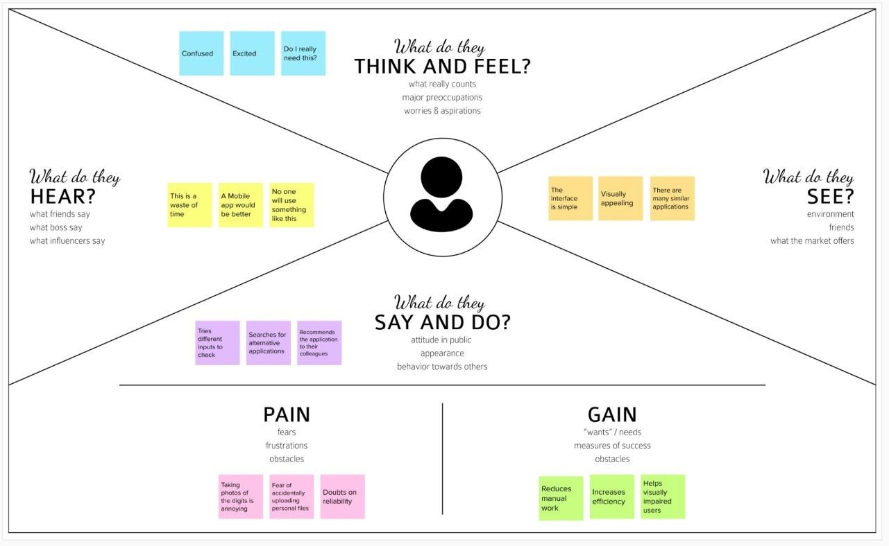

**IDEATION & BRAINSTORMING**

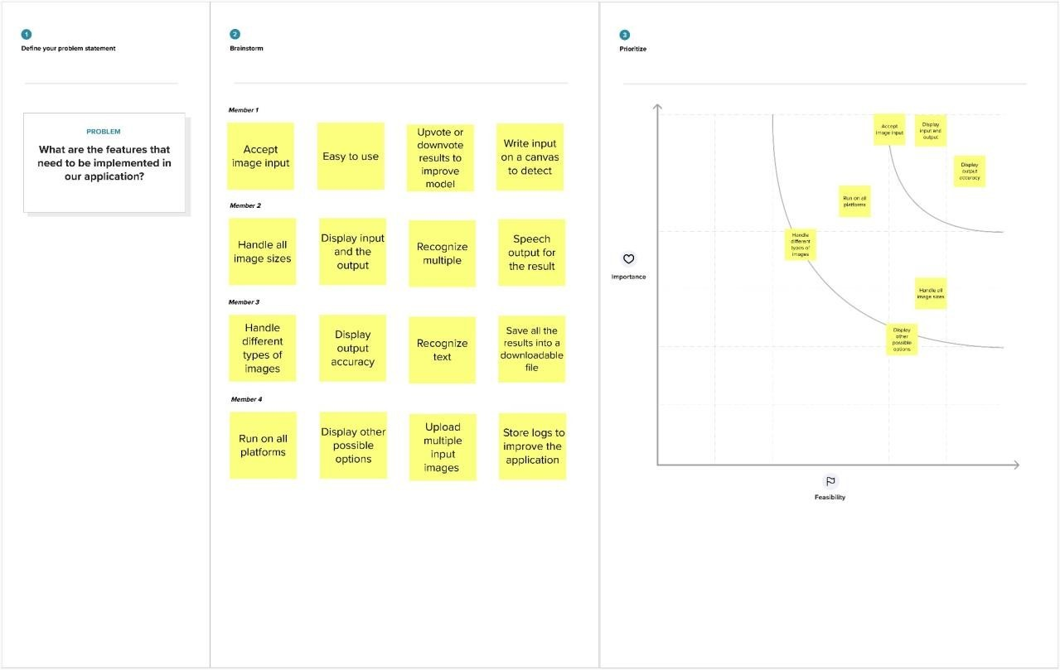

**PROPOSED SOLUTION**

|  |  |  |
| --- | --- | --- |
| **S.NO** | **PARAMETER** | **DESCRIPTION** |
| 1 | Problem Statement | To create an application that recognizes handwritten digits |
| 2 | Idea / Solution Description | The application takes an image as the input and accurately detects the digits in it. |
| 3 | Novelty / Uniqueness | Instead of recognizing every text, the application accurately recognizes only the digits |
| 4 | Social Impact / Customer Satisfaction | This application reduces the manual tasks that need to be performed. This improves productivity in the workplace. |
| 5 | Business Model | The application can be integrated with traffic  surveillance cameras to  recognize vehicle number plates    The application can be integrated with Postal systems to recognize the pin codes  effectively |
| 6 | Scalability of the Solution | The application can easily be scaled to accept multiple inputs  and process them parallelly to further increase efficiency |

**PROBLEM SOLUTION FIT**

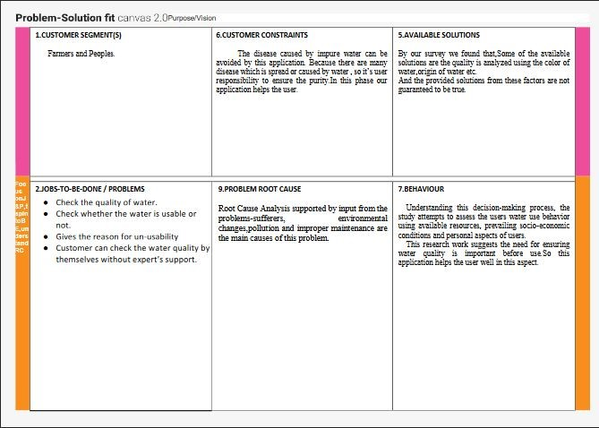



**CHAPTER 4**

##### REQUIREMENT ANALYSIS

FUNCTIONAL REQUIREMENTS

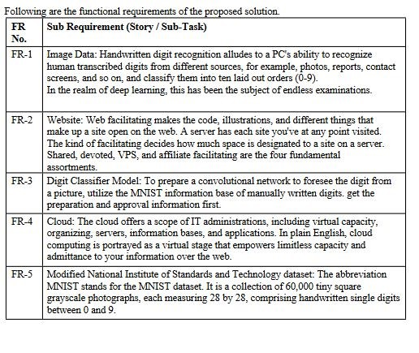

**NON FUNCTIONAL REQUIREMENTS**

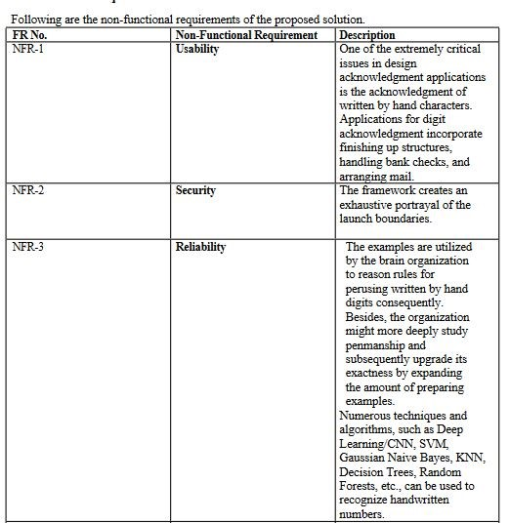

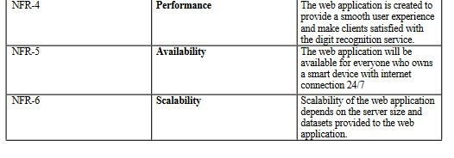

**CHAPTER 5**

##### PROJECT DESIGN

DATA FLOW DIAGRAM

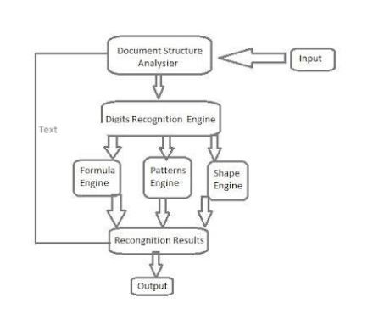

**SOLUTION & TECHNICAL ARCHITECTURE**

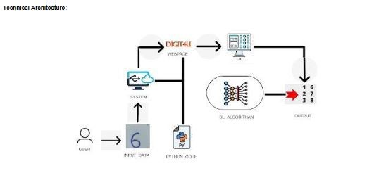

**USER STORIES**

|  |  |  |  |  |  |  |
| --- | --- | --- | --- | --- | --- | --- |
| User Type | Functional Requirements | User  Story  Number | User Story / Task | Acceptance Criteria | Priority | Release |
| Customer | Accessing the Application | USN-1 | As a user, I should be able to access the application from  anywhere and use on any devices | User can access the application using the browser on any device | High | Sprint-4 |
| Uploading Image | USN-2 | As a user, I should be able to upload images to predict the digits | User can upload images | High | Sprint-3 |
| Viewing the Results | USN-3 | As a user, I should be able to view the results | The result of the prediction is displayed | High | Sprint-3 |
| Viewing Other Prediction | USN-4 | As a user, I should be able to see other close predictions | The accuracy of other values must be displayed | Medium | Sprint-4 |
| Usage  Instruction | USN-5 | As a user, I should have a usage  instruction to know  how to use the application | The usage instruction is displayed on the home  page | Medium | Sprint-4 |

# CHAPTER 6

# PROJECT PLANNING AND SCHEDULING

### SPRINT PLANNING AND ESTIMATION

|  |  |  |  |  |
| --- | --- | --- | --- | --- |
| **SPRINT** | **USER STORY / TASK** | **STORY**  **POINTS** | **PRIORITY** | **TEAM MEMBERS** |
| Sprint - I | Get the dataset | 3 | High | Eashwar Karthik V |
| Explore the data | 2 | Medium | Eashwar Karthik V Hemesh M |
| Data Pre-Processing | 3 | High | Hareesh R GowthamenRaj R |
| Prepare training and testing data | 3 | High | Hareesh R Gowthamen Raj R |
| Sprint - II | Create the model | 3 | High | Hareesh R |
| Train the model | 3 | High | Gowthamen Raj R |
| Test the model | 3 | High | Hemesh M |
| Sprint - III | Improve the model | 2 | Medium | Hareesh R Gowthamen Raj R |
| Save the model | 3 | High | Eashwar Karthik |
| Build the Home Page | 3 | High | Hemesh M  Eashwar Karthik V |
| Setup a database to store input images | 2 | Medium | Hareesh R |
| Sprint - IV | Build the results page | 3 | High | Gowthamen Raj R  Hareesh R |
|  | Integrate the model with the application | 3 | High | Hemesh M  Hareesh R |
| Test the application | 3 | High | Hareesh R |

#### SPRINT DELIVERY SCHEDULE

|  |  |  |  |  |  |  |
| --- | --- | --- | --- | --- | --- | --- |
| **SPRINT** | **TOTAL**  **STORY**  **POINTS** | **DURATION** | **SPRINT**  **START**  **DATE** | **SPRINT**  **END DATE**  **(PLANNED)** | **STORY**  **POINTS**  **COMPLETED**  **(AS ON**  **PLANNED**  **DATE)** | **SPRINT**  **RELEASE DATE**  **(ACTUAL)** |
| Sprint - I | 11 | 6 Days | 24 Oct 2022 | 29 Oct 2022 | 11 | 29 Oct 2022 |
| Sprint - II | 9 | 6 Days | 31 Oct 2022 | 05 Nov 2022 | 9 | 05 Nov 2022 |
| Sprint - III | 10 | 6 Days | 07 Oct 2022 | 12 Nov 2022 | 10 | 12 Nov 2022 |
| Sprint - IV | 9 | 6 Days | 14 Nov 2022 | 19 Nov 2022 | 9 | 19 Nov 2022 |

# CHAPTER 7

# CODING & SOLUTIONING

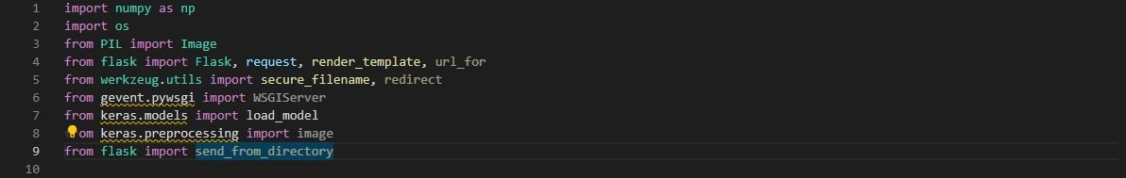

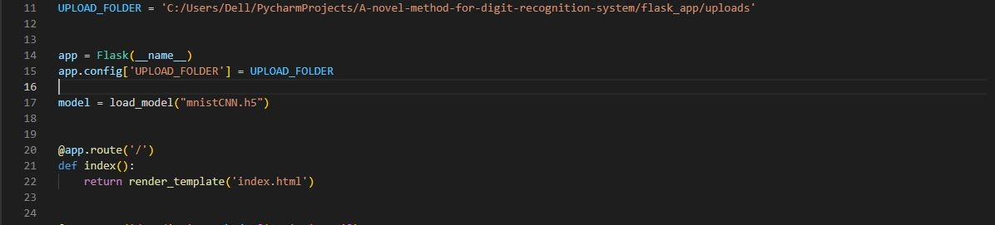

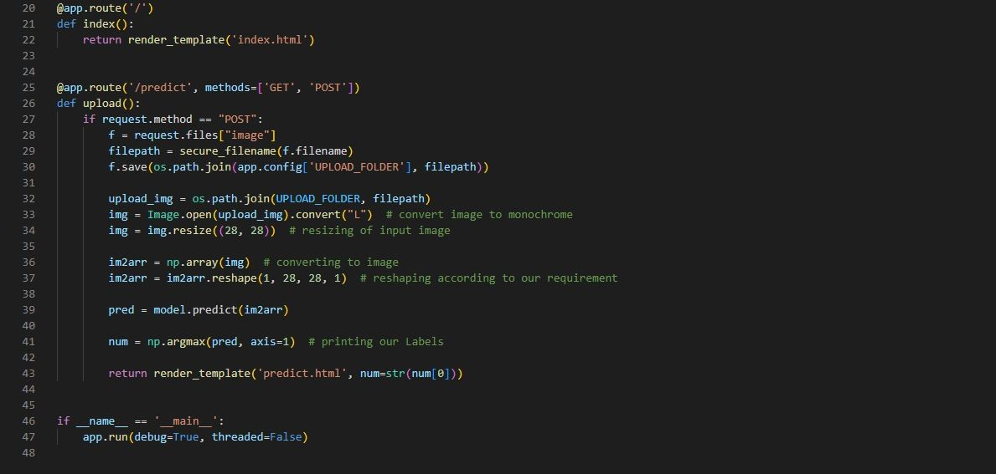

# 

# 

**CHAPTER 8**

**TESTING**

**TEST CASES**

|  |  |  |  |  |  |  |
| --- | --- | --- | --- | --- | --- | --- |
| **Test case**  **ID** | **Feature**  **Type** | **Component** | **Test**    **Scenario** | **Expected Result** | **Actual Result** | **Status** |
| HP_TC_001 | UI | Home Page | Verify UI elements in  the Home  Page | The Home page must be displayed properly | Working as expected | FAIL |
| HP_TC_002 | UI | Home Page | Check if the UI elements are displayed  properly in different screen sizes | The Home page must be displayed properly in all sizes | The UI is not displayed  properly in  screen size  2560 x 1801 and 768 x 630 | FAIL |
| HP_TC_003 | Functional | Home Page | Check if user can upload their file | The input image should be  uploaded to the application successfully | Working as expected | PASS |
| HP_TC_004 | Functional | Home Page | Check if user cannot upload unsupported  files | The application should not allow user to select a non image file | User is able to upload any file | FAIL |
| HP_TC_005 | Functional | Home Page | Check if the page redirects to the result  page once the input is given | The page should redirect to the results page | Working as expected | PASS |

|  |  |  |  |  |  |  |
| --- | --- | --- | --- | --- | --- | --- |
| BE_TC_001 | Functional | Backend | Check if all the routes are working properly | All the routes should properly work | Working as expected | PASS |
| M_TC_001 | Functional | Model | Check if the model can  handle various image sizes | The model should  rescale the image  and predict the results | Working as expected | PASS |
| M_TC_002 | Functional | Model | Check if the model  predicts the digit | The model should predict the number | Working as expected | PASS |
| M_TC_003 | Functional | Model | Check if the model can handle  complex input image | The model should predict the  number in the complex image | The model fails to identify the  digit since the model is not  built to handle such data | FAIL |
| RP_TC_001 | UI | Result Page | Verify UI elements in  the Result  Page | The Result page must be displayed properly | Working as expected | PASS |
| RP_TC_002 | UI | Result Page | Check if the input image is  displayed properly | The input image should be  displayed properly | The size of the input image  exceeds the display container | FAIL |
| RP_TC_003 | UI | Result Page | Check if the result is  displayed properly | The result should be displayed properly | Working as expected | PASS |
| RP_TC_004 | UI | Result Page | Check if the other  predictions  are displayed properly | The other predictions should be displayed properly | Working as expected | PASS |

#### USER ACCEPTANCE TESTING

###### DEFECT ANALYSIS

|  |  |  |  |  |  |
| --- | --- | --- | --- | --- | --- |
| Resolution | Severity 1 | Severity 2 | Severity 3 | Severity 4 | Total |
| By Design | 1 | 0 | 1 | 0 | 2 |
| Duplicate | 0 | 0 | 0 | 0 | 0 |
| External | 0 | 0 | 2 | 0 | 2 |
| Fixed | 4 | 1 | 0 | 1 | 6 |
| Not Reproduced | 0 | 0 | 0 | 1 | 1 |
| Skipped | 0 | 0 | 0 | 1 | 1 |
| Won’t Fix | 1 | 0 | 1 | 0 | 2 |
| Total | 6 | 1 | 4 | 3 | 14 |

**TEST CASE ANALYSIS**

|  |  |  |  |  |
| --- | --- | --- | --- | --- |
| Section | Total Cases | Not Tested | Fail | Pass |
| Client Application | 10 | 0 | 3 | 7 |
| Security | 2 | 0 | 1 | 1 |
| Performance | 3 | 0 | 1 | 2 |
| Exception Reporting | 2 | 0 | 0 | 2 |

**CHAPTER 9**

# RESULTS

### PERFORMANCE METRICS

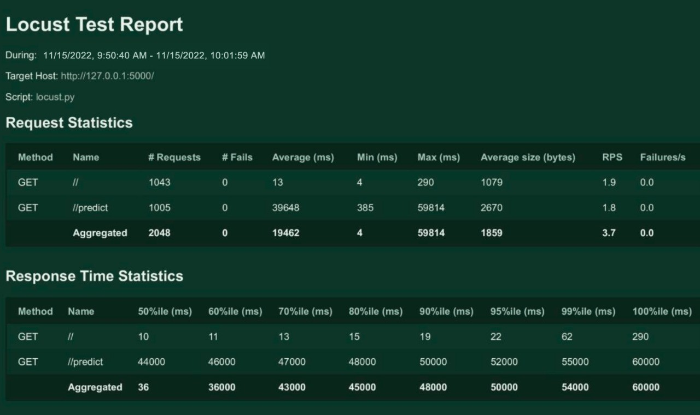

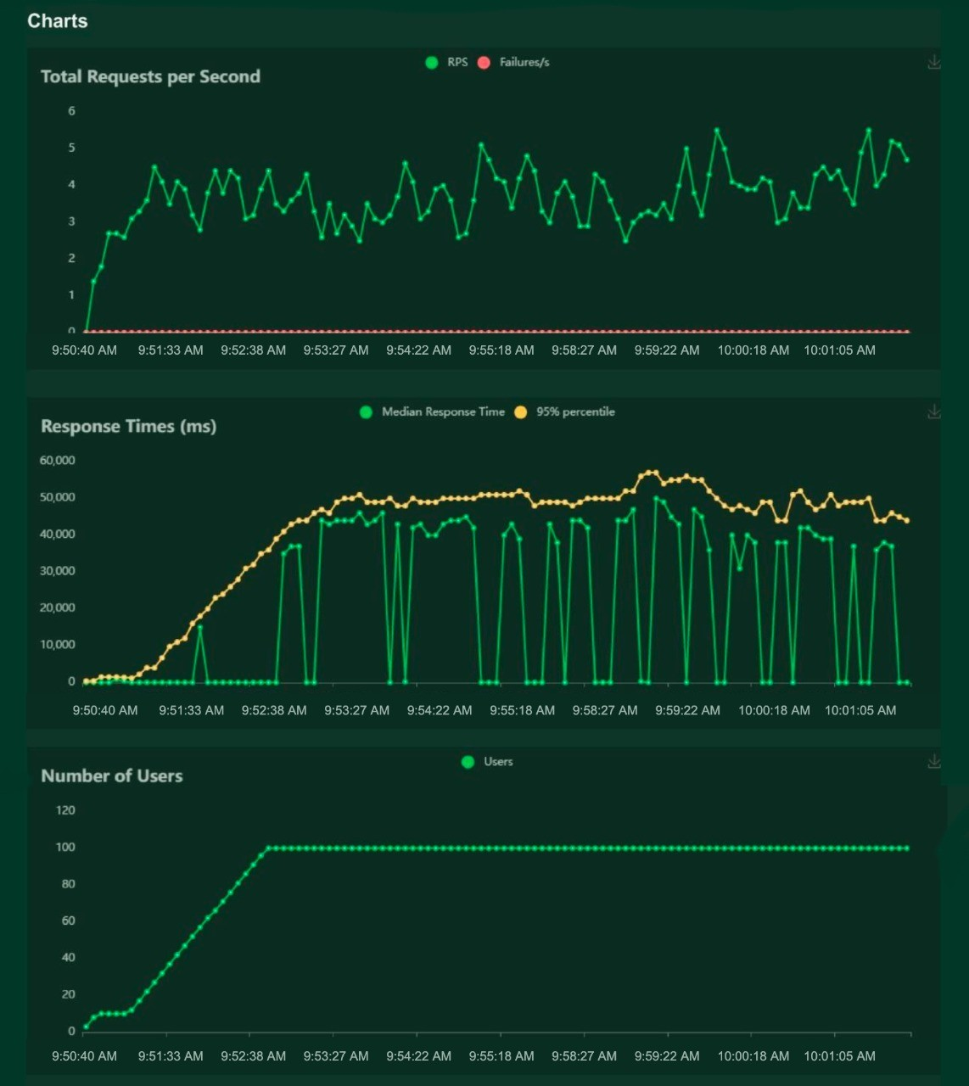

**CHAPTER 10**

# ADVANTAGES & DISADVANTAGES

## ADVANTAGES

* Reduces manual work
* More accurate than average human
* Capable of handling a lot of data
* Can be used anywhere from any device

## DISADVANTAGES

* Cannot handle complex data
* All the data must be in digital format
* Requires a high performance server for faster predictions
* Prone to occasional errors

**CHAPTER 11**

# CONCLUSION

This project demonstrated a web application that uses machine learning to recognise handwritten numbers. Flask, HTML, CSS, JavaScript, and a few other technologies were used to create this project. The model predicts the handwritten digit using a CNN network. During testing, the model achieved a 99.61% recognition rate. The proposed project is scalable and can easily handle a huge number of users. Since it is a web application, it is compatible with any device that can run a browser. This project is extremely useful in real-world scenarios such as recognizing number plates of vehicles, processing bank cheque amounts, numeric entries in forms filled up by hand (tax forms) and so on. There is so much room for improvement, which can be implemented in subsequent versions.

**CHAPTER 12**

# FUTURE SCOPE

This project is far from complete and there is a lot of room for improvement. Some of the improvements that can be made to this project are as follows:

* Add support to detect from digits multiple images and save the results
* Add support to detect multiple digits
* Improve model to detect digits from complex images
* Add support to different languages to help users from all over the world

This project has endless potential and can always be enhanced to become better. Implementing this concept in the real world will benefit several industries and reduce the workload on many workers, enhancing overall work efficiency.

# APPENDIX

## SOURCE CODE

MODEL CREATION

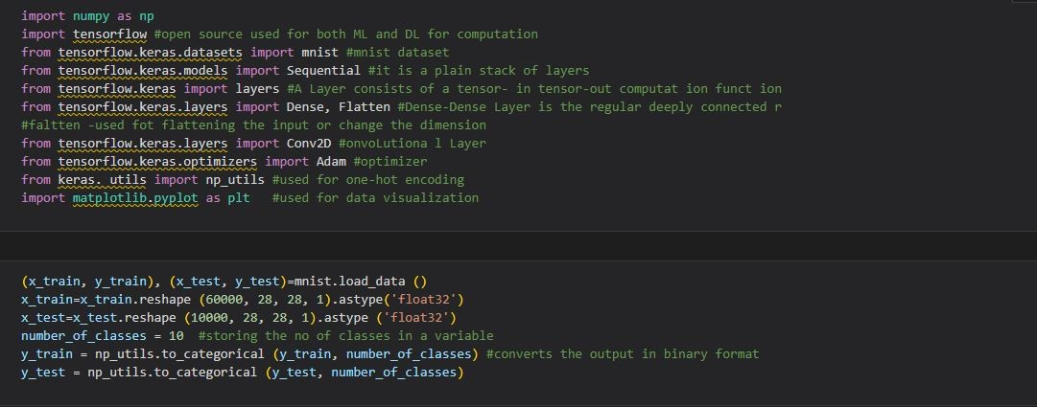

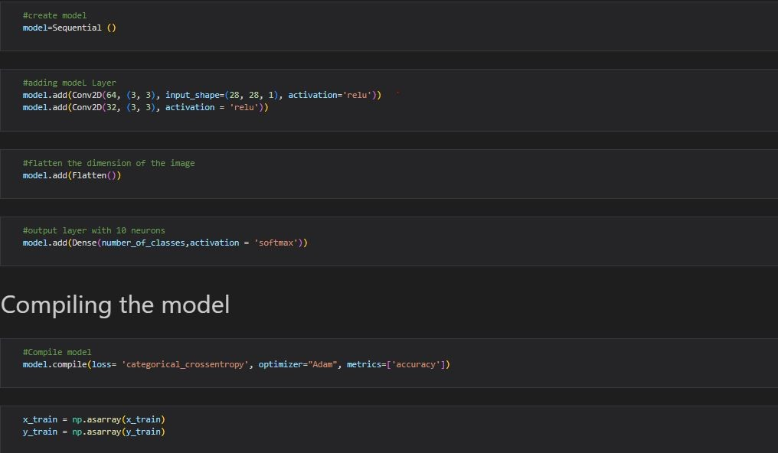

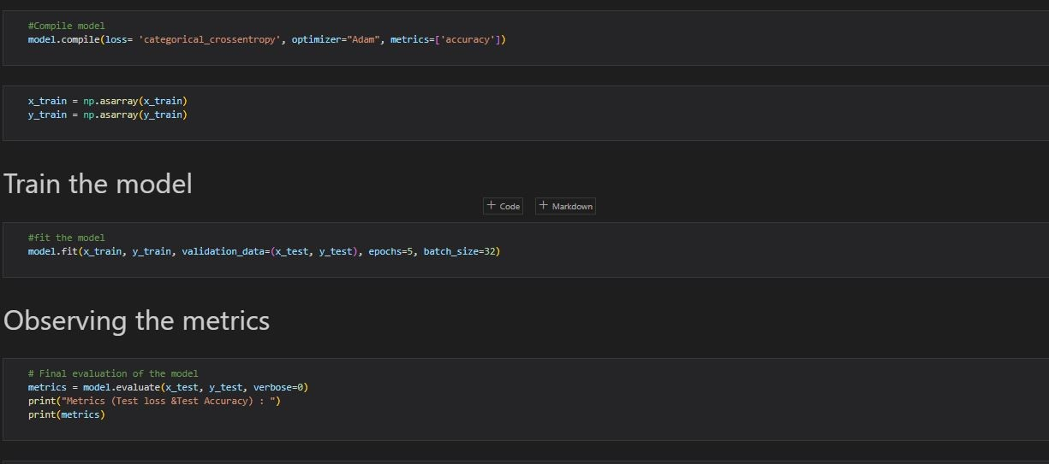

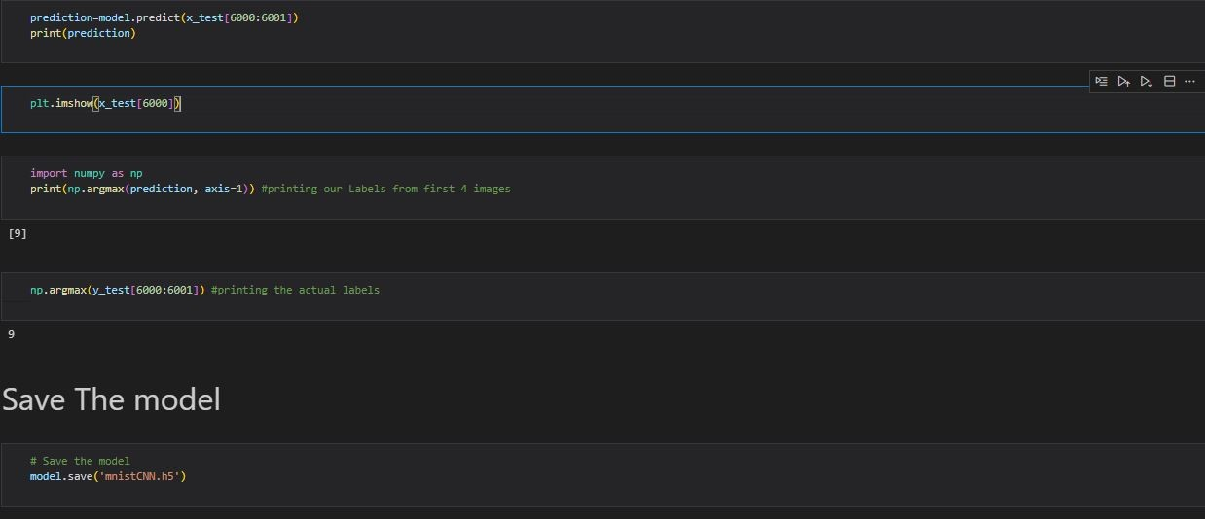

FLASK APP



HOME PAGE (HTML)

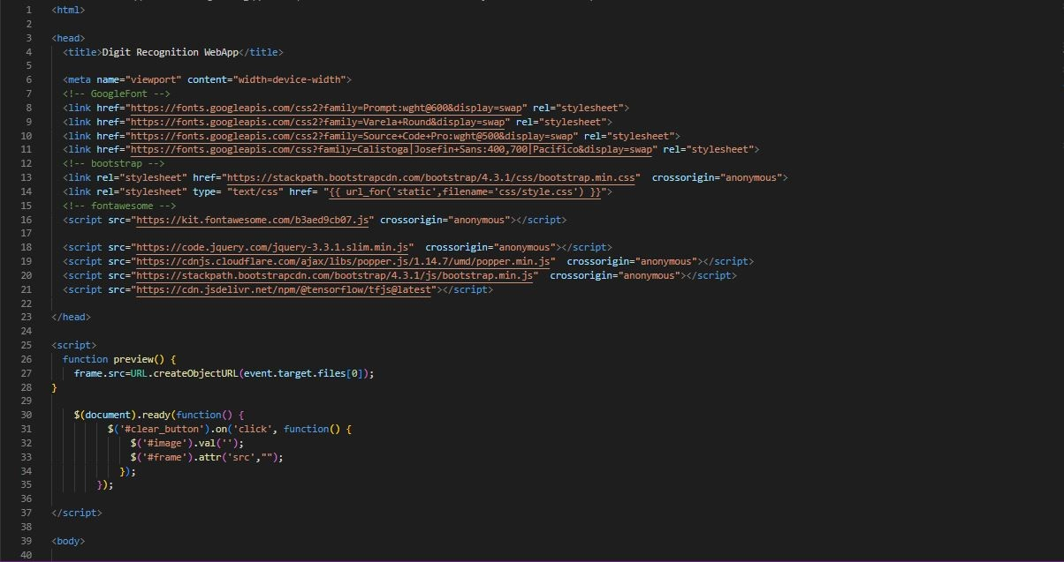

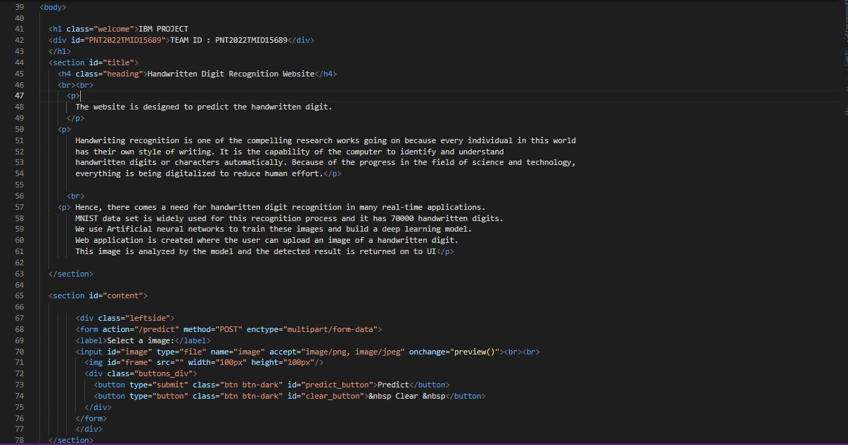

HOME PAGE (CSS)

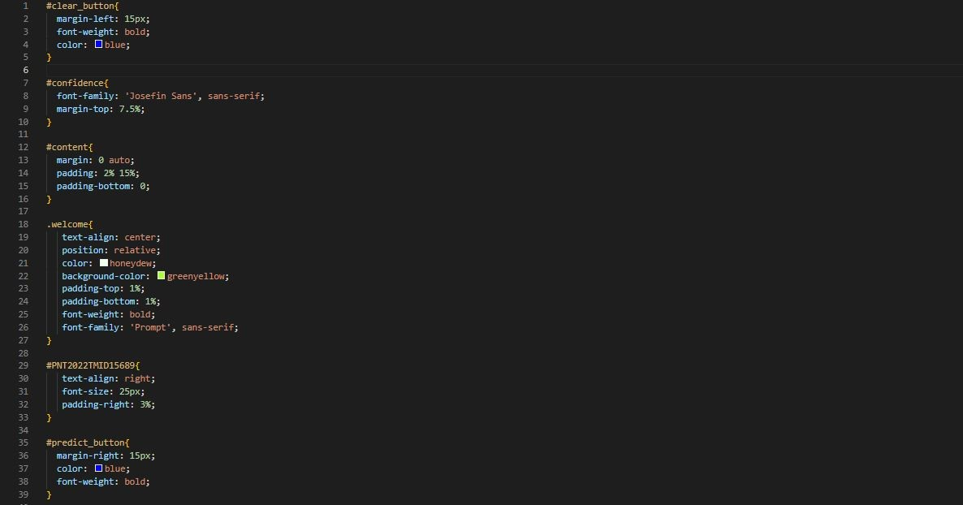

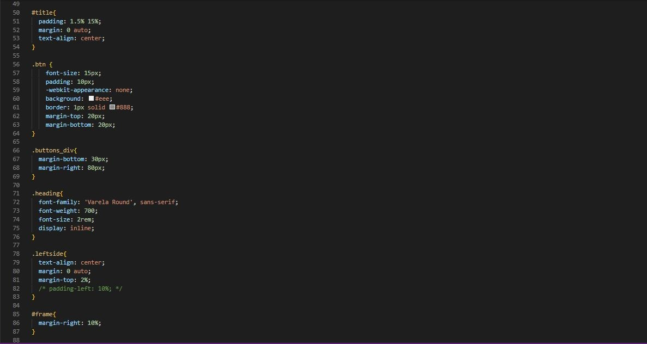

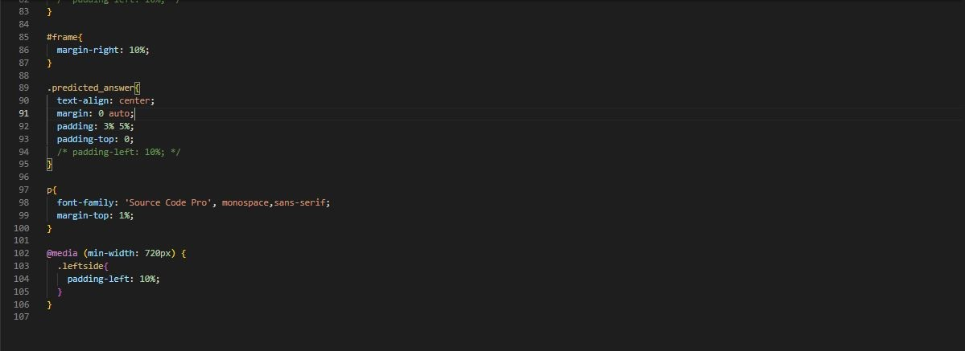

HOME PAGE (JS)



PREDICT PAGE (HTML)

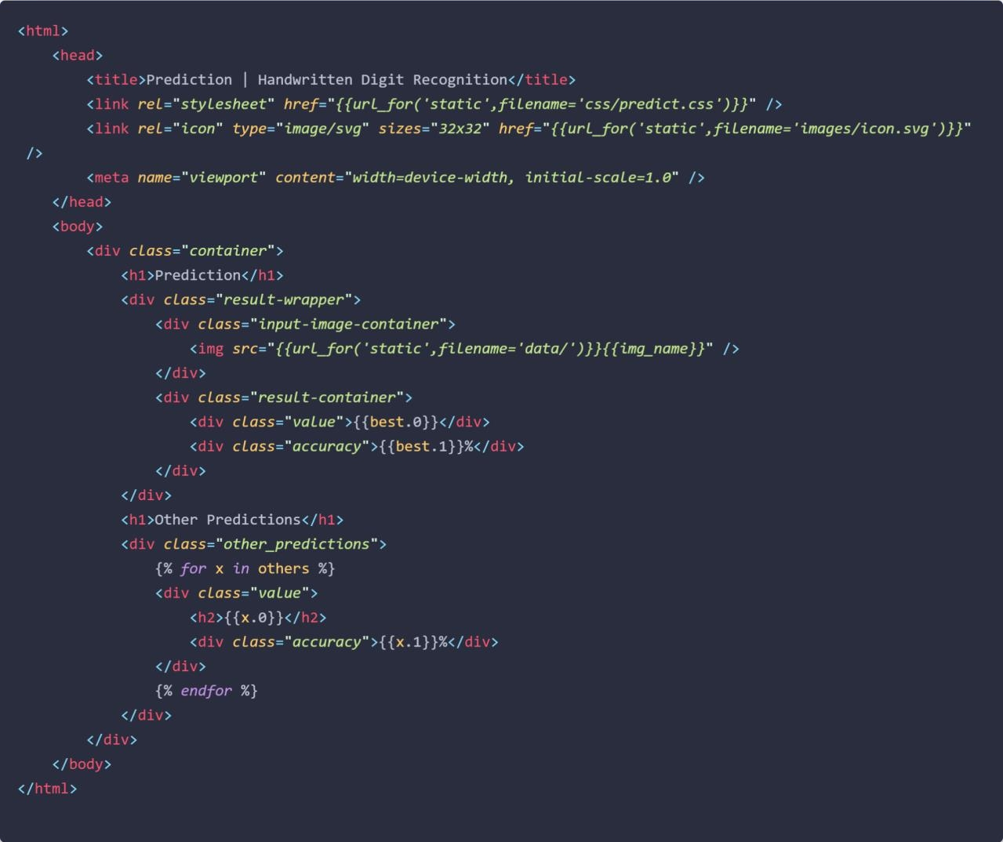

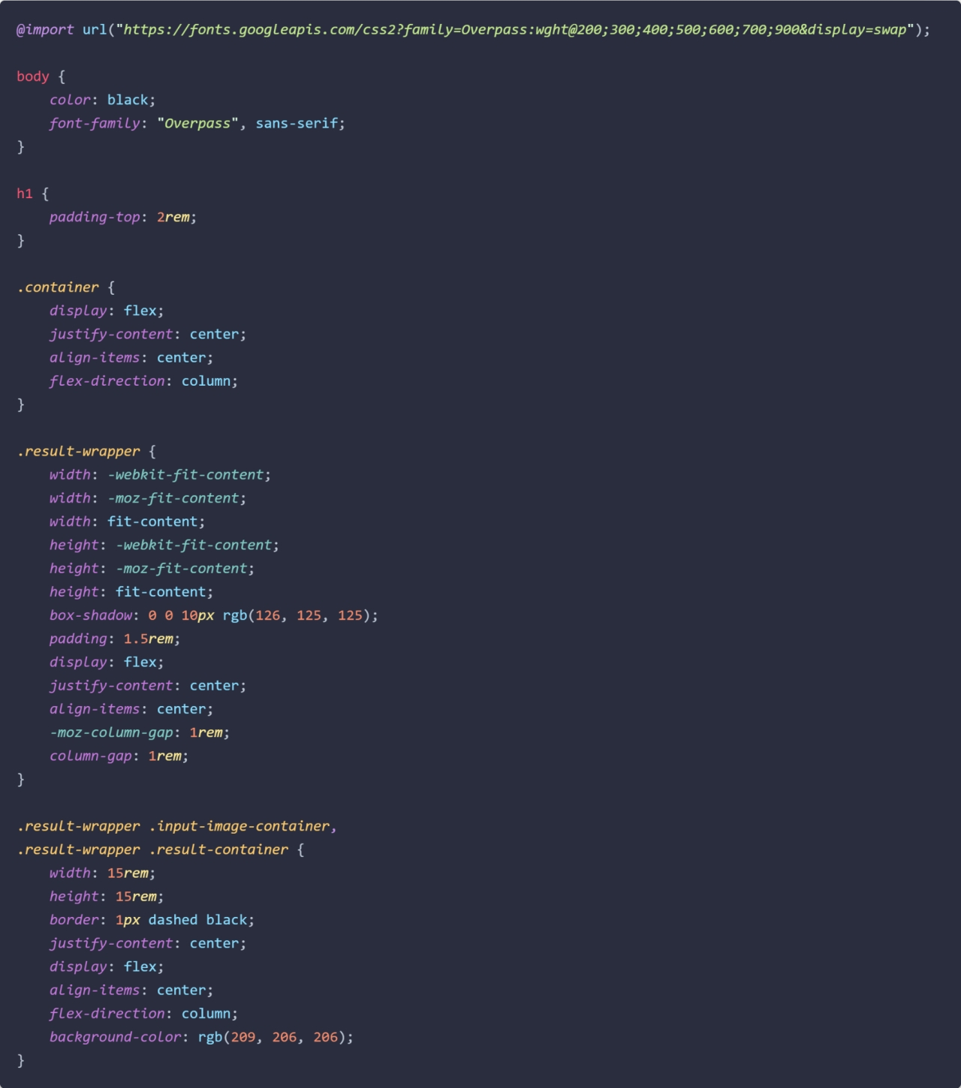

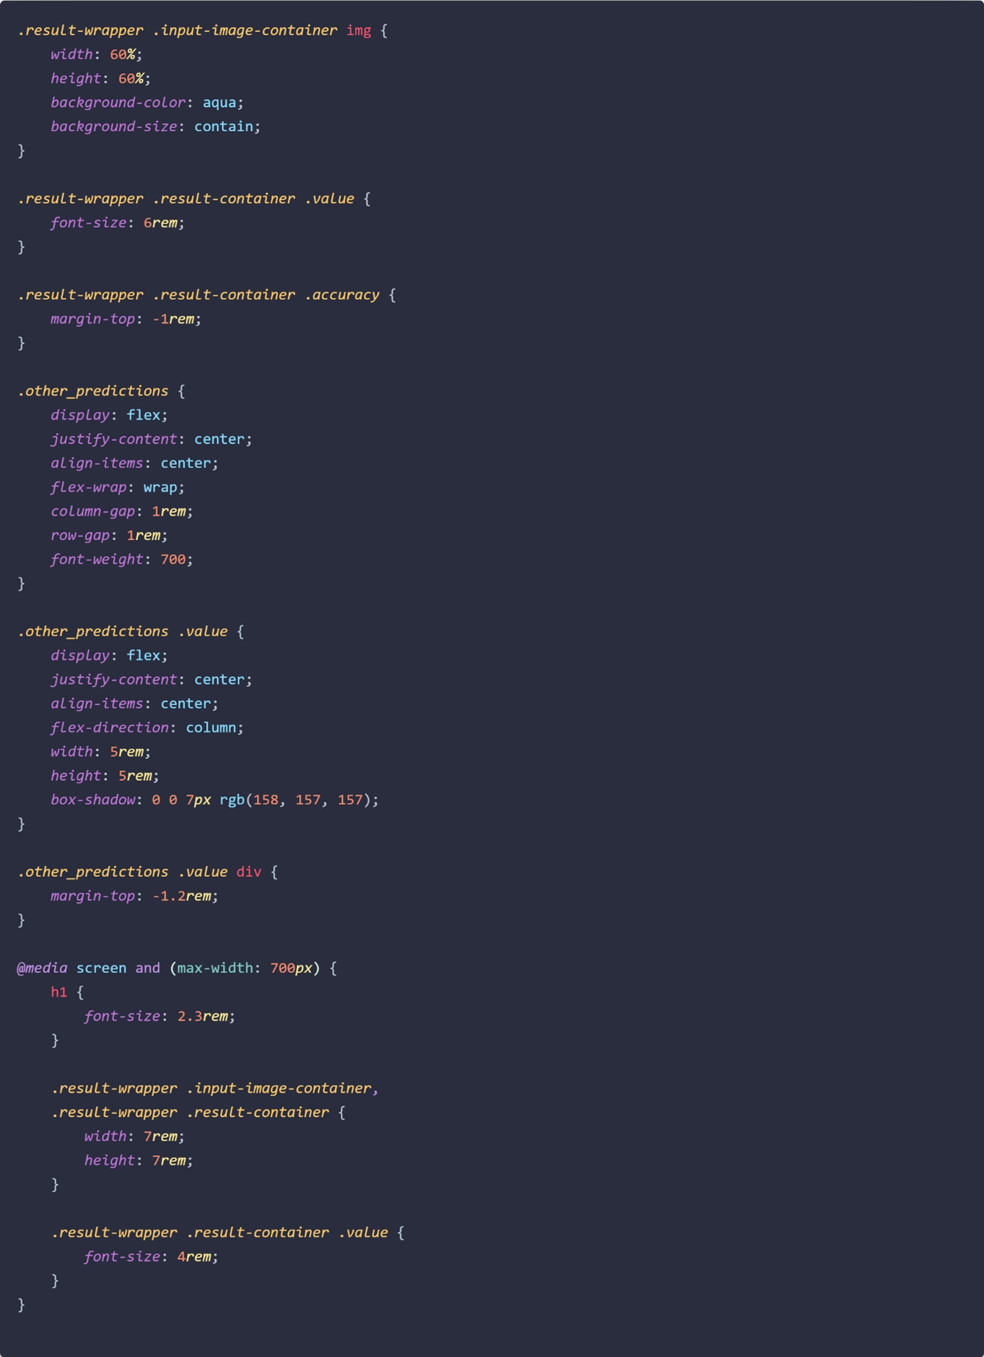

## GITHUB

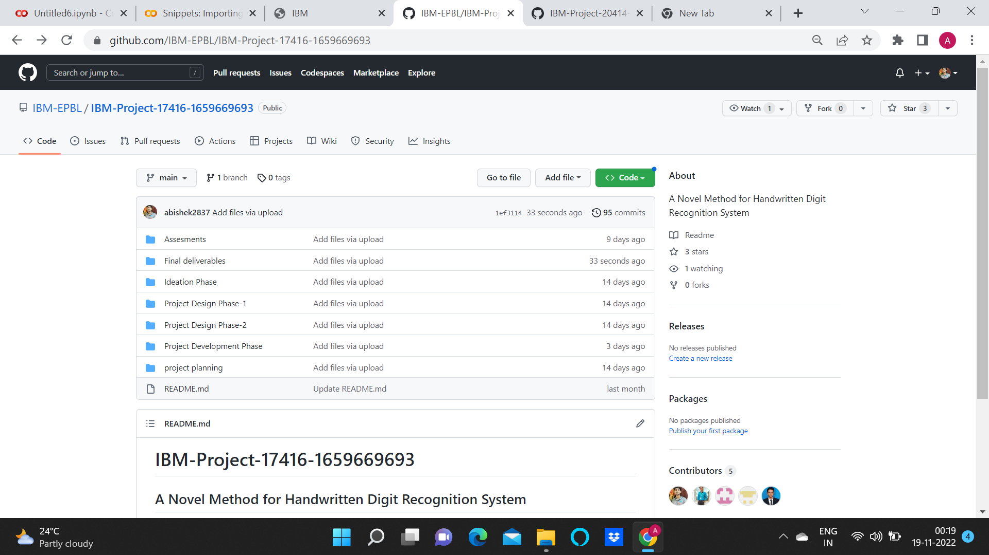

**GITHUB LINK:**

<https://github.com/IBM-EPBL/IBM-Project-17416-1659669693>